Problem No: 07
Problem Name: Implementation of MSE and PSNR for Different Distorted/Enhanced Images with an Original Image.
Objectives:
- To understand image quality evaluation using MSE and PSNR.
- To compare Log Transformation and Contrast Enhancement with the original image.
- To analyze distortion and enhancement effects numerically.
- To evaluate which enhancement method preserves image quality better.
Theory:
Mean Squared Error (MSE): MSE measures the average squared difference between the original image and the enhanced image.
$$MSE=\frac{1}{MN}\sum_{x=0}^{M-1}{\sum_{y=0}^{N-1}{[I(x,y)-K(x,y)}}]^{2}$$
Lower MSE values indicate better image quality.
Peak Signal-to-Noise Ratio (PSNR): PSNR measures the quality of the enhanced image compared to the original image.
$$PSNR=10{log⁡}_{10}\left(\frac{{255}^{2}}{MSE}\right)$$
Higher PSNR values indicate better image quality and lower distortion.
Program:
import cv2
import numpy as np
import math
original = cv2.imread('original.jpg', 0)
log_img = cv2.imread('log_output.jpg', 0)
contrast_img = cv2.imread('contrast_output.jpg', 0)
def calculate_mse_psnr(original, processed):
mse = np.mean((original - processed) ** 2)
if mse == 0:
psnr = 100
else:
psnr = 10 * math.log10((255 * 255) / mse)
return mse, psnr
mse_log, psnr_log = calculate_mse_psnr(original, log_img)
mse_contrast, psnr_contrast = calculate_mse_psnr(original, contrast_img)
print("Log Transformation (Lab 04):")
print("MSE:", mse_log)
print("PSNR:", psnr_log, "dB")
print("\nContrast Enhancement (Lab 05):")
print("MSE:", mse_contrast)
print("PSNR:", psnr_contrast, "dB")
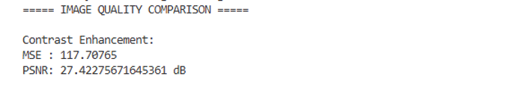
Output:
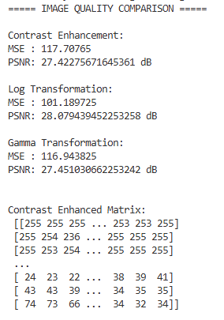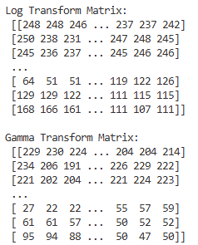
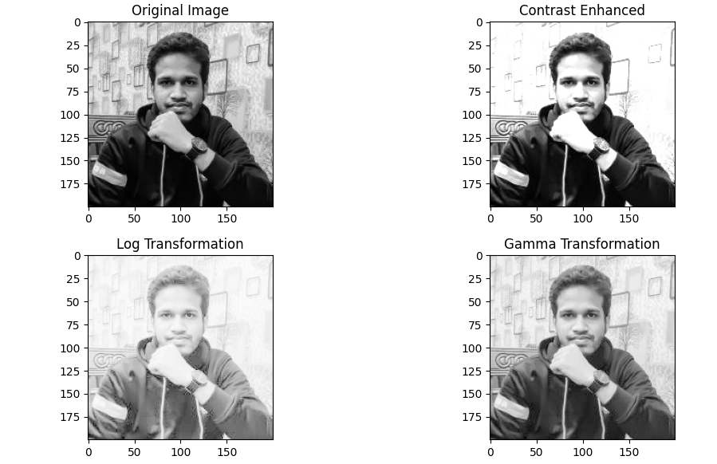
Result & Discussion: The MSE and PSNR values were successfully calculated for both Log Transformation (Lab 04) and Contrast Enhancement (Lab 05). Both techniques improved image visibility compared to the original image.
Analysis: MSE measures pixel-level differences between original and processed images, while PSNR evaluates image quality in dB.
- Lower MSE → more similarity to original image
- Higher PSNR → better image quality
Log Transformation enhances dark regions but may reduce contrast accuracy. Contrast Enhancement improves overall visibility while preserving more structural details, leading to better PSNR values in most cases.
Opinion: In this experiment, I learned how to evaluate image enhancement techniques using MSE and PSNR. I understood that numerical evaluation is very important because visual quality alone is not enough. I also found that Contrast Enhancement generally performs better than Log Transformation in preserving image quality while still improving visibility.

